Client Intake Form – Therapeutic Massage

Personal Information:

Name Phone (Day) Phone (Eve) Address City/State/Zip email Date of Birth Occupation Emergency Contact Phone

The following information will be used to help plan safe and effective massage sessions. Please answer the questions to the best of your knowledge.

Date of Initial Visit
- Have you had a professional massage before? Yes No
If yes, how often do you receive massage therapy?
- Do you have any difficulty lying on your front, back, or side? Yes No
If yes, please explain
- Do you have any allergies to oils, lotions, or ointments? Yes No
If yes, please explain
- Do you have sensitive skin? Yes No
- Are you wearing contact lenses ( ) dentures ( ) a hearing aid ( ) ?
- Do you sit for long hours at a workstation, computer, or driving? Yes No
If yes, please describe
- Do you perform any repetitive movement in your work, sports, or hobby? Yes No
If yes, please describe
- Do you experience stress in your work, family, or other aspect of your life? Yes No If yes, how do you think it has affected your health?
muscle tension ( ) anxiety ( ) insomnia ( ) irritability ( ) other
- Is there a particular area of the body where you are experiencing tension, stiffness, pain or other discomfort? Yes No
If yes, please identify
- Do you have any particular goals in mind for this massage session? Yes No
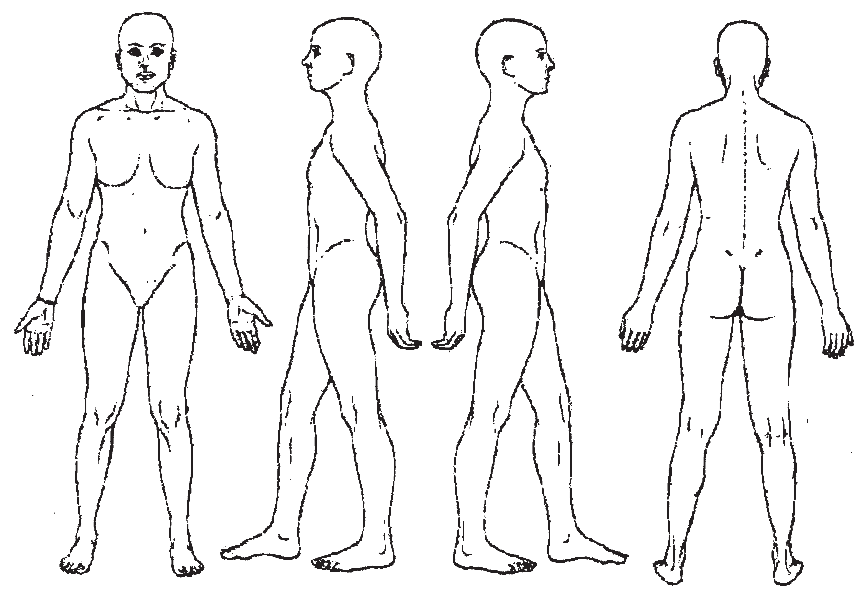
If yes, please explain

Circle any specific areas you would like the massage therapist to concentrate on during the session:

Medical History

In order to plan a massage session that is safe and effective, I need some general information about your medical history.

- Are you currently under medical supervision? Yes No
If yes, please explain
- Do you see a chiropractor? Yes No If yes, how often?
- Are you currently taking any medication? Yes No
If yes, please list
- Please check any condition listed below that applies to you:

( ) contagious skin condition ( ) open sores or wounds
( ) easy bruising
( ) recent accident or injury ( ) recent fracture
( ) recent surgery ( ) artificial joint
( ) sprains/strains ( ) current fever
( ) swollen glands
( ) allergies/sensitivity ( ) heart condition
( ) high or low blood pressure ( ) circulatory disorder
( ) varicose veins ( ) atherosclerosis
( ) phlebitis
( ) deep vein thrombosis/blood clots
( ) joint disorder/rheumatoid arthritis/osteoarthritis/tendonitis ( ) osteoporosis
( ) epilepsy
( ) headaches/migraines ( ) cancer
( ) diabetes
( ) decreased sensation ( ) back/neck problems ( ) Fibromyalgia
( ) TMJ
( ) carpal tunnel syndrome ( ) tennis elbow
( ) pregnancy If yes, how many months?

Please explain any condition that you have marked above

- Is there anything else about your health history that you think would be useful for your massage practitioner to
know to plan a safe and effective massage session for you?

Draping will be used during the session – only the area being worked on will be uncovered.
Clients under the age of 17 must be accompanied by a parent or legal guardian during the entire session. Informed written consent must be provided by parent or legal guardian for any client under the age of 17.

I, (print name) understand that the massage I receive is provided for the basic purpose of relaxation and relief of muscular tension. If I experience any pain or discomfort during this session, I will immediately inform the therapist so that the pressure and/or strokes may be adjusted to my level of comfort. I further understand that massage should not be construed as a substitute for medical examination, diagnosis, or treatment and that I should see a physician, chiropractor or other qualified medical specialist for any mental or physical ailment that I am aware of. I understand that massage therapists are not qualified to perform spinal or skeletal adjustments, diagnose, prescribe, or treat any physical or mental illness, and that nothing said in the course of the session given should be construed as such. Because massage should not be performed under certain medical conditions, I affirm that I have stated all my known medical conditions, and answered all questions honestly. I agree to keep the therapist updated as to any changes in my medical profile and understand that there shall be no liability on the therapist’s part should I fail to do so.

Signature of client Date

Signature of Massage Therapist Date

